**612/1**

**IPS**

**Art & Crafts**

**Paper 1**

**Jul/Aug 2016**

**2 hours**

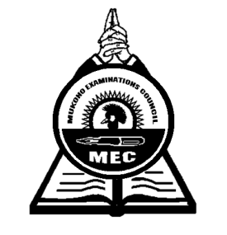

**MUKONO EXAMINATIONS COUNCIL**

**Uganda Certificate of Education**

**IPS ART AND CRAFTS**

STUDIO TECHNOLOGY

Paper 1

2 hours

**INSTRUCTIONS TO CANDIDATES**

*Answer* ***all*** *questions*

*Drawings and Diagrams should be used where necessary*

1. (a) Define the term Sculpture ***(02 mark)***

(b) Describe any four categories of sculpture according to the media ***(04 marks)***

1. Explain any four types of fabric decoration ***(04 marks)***

1. Mention with illustrations any three tools used in wood curving ***(03 marks)***

1. Define the following:
2. Mallet ***(02 mark)***
3. Chisel ***(02 mark)***
4. Serigraphy ***(02 mark)***
5. Motif ***(02 mark)***
6. (a) Why is clay an important material in Art and Craft? ***(02 marks)***

(b) Mention four techniques used in Pottery ***(04 marks)***

6. (a) What substance is applied to printing paste to make it permanent? ***(02 marks)***

(b) Describe the process of screen printing that you know ***(05 marks)***

7. Distinguish between the following:

(i) Warm and cool colours ***(02 marks)***

(ii) Tertiary and complimentary colors  ***(02 marks)***

8. Explain the process of making Leather  ***(04 marks)***

9. (a) Define the term spinning ***(02 marks)***

(b) Mention any two types of Fibres you know ***(02 marks)***

10. What is the importance of studying Studio Art Technology? ***(04 marks)***

***End-***